
PB-T2/BIQP/1221/B 21-APR-2022
PRE BOARD EXAMINATION 3 -TERM 2 (2021-22)
Subject:BIOLOGY  Grade: XII |  | Max. Marks: 35  Time:2 Hrs
General Instructions:
i) All questions are compulsory.
ii) The question paper has three sections and 13 questions. All questions are compulsory.
iii) Section–A has 6 questions of 2 marks each; Section–B has 6 questions of 3 marks each; and Section–C has a case-based question of 5 marks.
iv) There is no overall choice. However, internal choices have been provided in some questions. A student has to attempt only one of the alternatives in such questions.
v) Wherever necessary, neat and properly labelled diagrams should be drawn.
SECTION A
1. | A child gets colostrum and polio drop both as an infant .Compare their mode of action with respect to our immune system. |  | 2
2. | Certain diseases are spread by mosquitoes and two such diseases are spread By a mosquito which bites in the day time. Both the diseases are caused by viruses.  a) Name the mosquito. b) Name the diseases with one symptom of each. |  | 2
3. | Give four examples to prove that microbes release gases during metabolism. |  | 2
4. | a) What does the diagram represent?  b) Explain in brief the process going on.  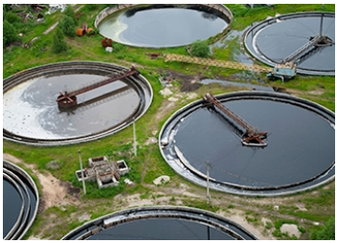 |  | 2
5 | - Identify the interaction related to the picture given below.  - Who is benefitted in this association and how?  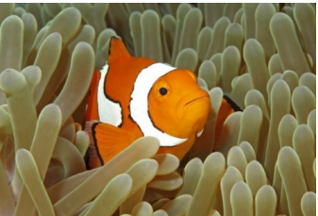  OR  - What do you understand by co-evolution in parasitism  - In accordance with their life styles, which special adaptations parasites evolved? |  | 2
6 | Observe the global biodiversity distribution of the major plant taxa in the given diagram and answer the questions accordingly.  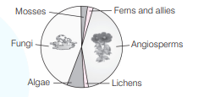  - Why are mosses/ferns so few? Give reason.  - How do fungi that are heterotrophs sustain themselves as a large population?  OR  Explain any two ways of ex situ other than zoological parks, botanical gardens and wildlife sanctuaries, by which threatened species of plants and animals are being conserved. |  | 2
SECTION B
7 | A doctor injected injured persons of a road accident with tetanus antitoxin.  (a) What is tetanus antitoxin?  (b) Why were the injured immediately injected with this antitoxin?  (c) Name the kind of immunity this injection provided |  | 3
8 | State the usefulness of the following microorganisms to humans.  (i) Nucleopolyhedrovirus  (ii) Saccharomyces cerevisiae  (iii) Monascus purpureus  (iv) Trichoderma polysporum  (v) Penicillium notatum  (vi) Propionibacterium shermanii |  | 3
9 | Eukaryotic cells have restriction endonucleases whereas prokaryotes lack the enzyme.  Do you agree with the above statement. Justify your answer. |  | 3
10 | The following figure depict linking of DNA  (a) Write the name of A and B.  (b) Complete the palindrome, which is recognized by EcoRI.  (c) Write the name of the enzyme that can link the two DNA fragments.  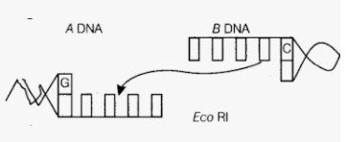 |  | 3
11 | - A population of Escherichia coli was grown in a culture medium. After 5 days, the culture medium became overcrowded with the bacterium and had depleted nutrients. What will happen to the population and what type of growth curve will the population attain?  (b) Draw the growth curve.  OR  Define ‘zero population growth rate’. Draw an age pyramid for the same |  | 3
12. | Explain rivet popper hypothesis. Name the ecologist who proposed it. |  | 3
SECTION C
13. | Read the following passage and answer the questions that follows.  Biotechnology deals with techniques of using live organisms to produce products useful to humans.  But this manipulation of living organisms is going without regulation. Therefore, some ethical  standards are required to evaluate the morality of human activities. In India, Government has setup  organization such as GEAC, which make decisions regarding the validity of GM research and patent issues  - What is a bio paptent?  - What do you mean by the term bioethics?  - What is biopiracy?  - Name any two Indian plants which are either been patented or attempts have been made to patent them by Western nations for their use?  - Expand GEAC  OR  Refer the following diagram and answer the questions that follow  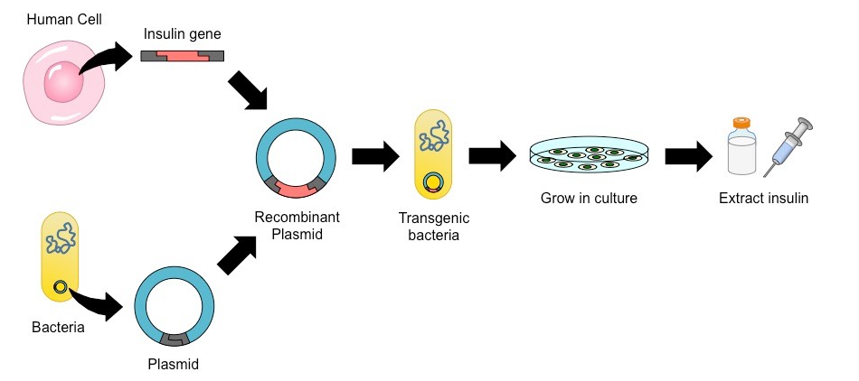  - Name the process which help in the production of insulin as per the given diagram.  - Name an enzyme that is utilized for cutting the molecule of DNA?  - What term was used to denote the insulin produced via this method and why it was termed so?  - Explain the steps involved in the manufacture of the product mentioned in the figure. |  | 5
***

